33.56:
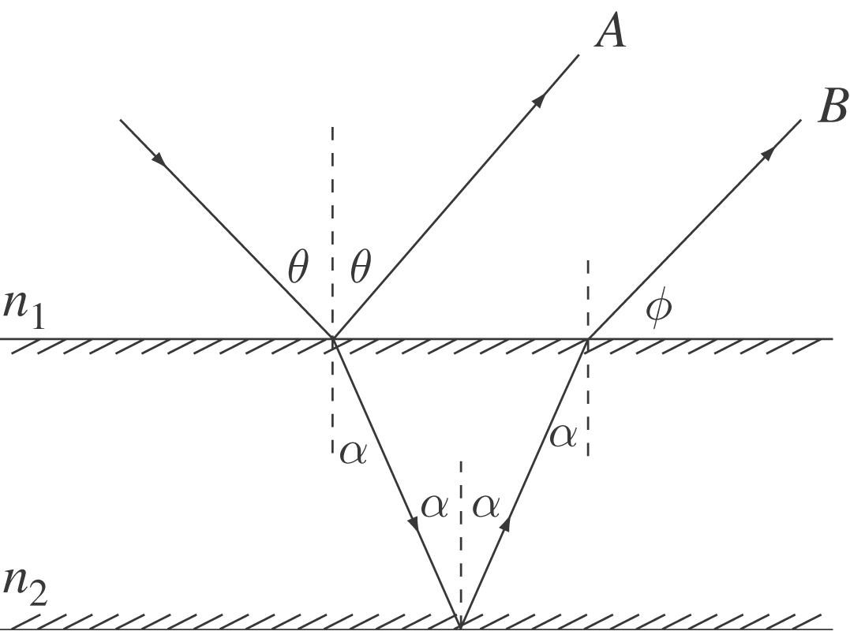

Direction of ray A: by law of reflection.
Direction of ray B:
At upper surface: 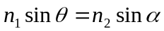
The lower surface reflects at Ray B returns to upper surface at angle of incidence 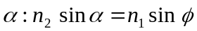
Thus
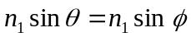
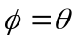
Therefore rays A and B are parallel.

